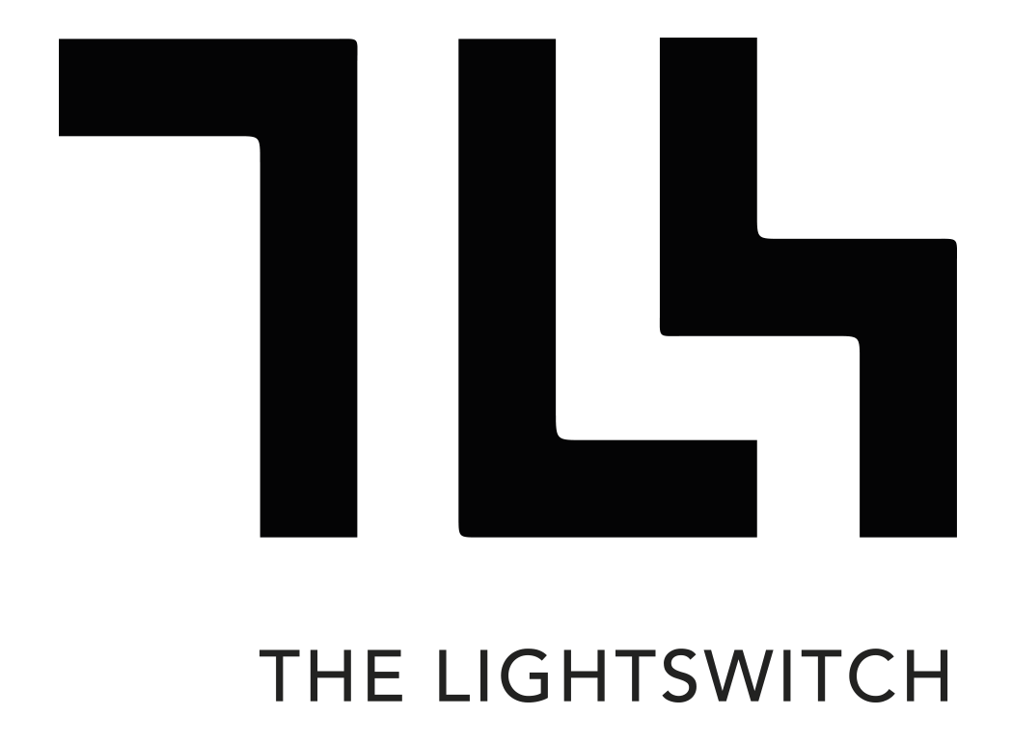USERS MANUAL

The Lightswitch Database & Security System

Asia Pacific College – SOFTDEV

January – April 08, 2015

Acknowledgement

We would just like to thank everyone who contributed in the planning, research, prototyping, and finalizing of all the data’s and documents found in this manual.

Members
Macasero, Jan Patrick
Moradillo, Ave Jay
Alonzo, Miguel Carlo

Professors
Sir Joe Gene Quesada

Brief Introduction

The system is about a webpage with features that can only be used or viewed by privileges members of the company. It has a built in database and a security feature to protect the company’s data.
USER'S MANUAL

TABLE OF CONTENTS

Page #

1.0 GENERAL INFORMATION
1.1 System Overview
1.2 Project References
1.3 Authorized Use Permission
1.4 Points of Contact
1.4.1 Information
1.5 Organization of the Manual
1.6 Acronyms and Abbreviations
2.0 SYSTEM SUMMARY
2.1 System Configuration
2.2 Data Flows
2.3 User Access Levels
2.4 Contingencies and Alternate Modes of Operation
3.0 GETTING STARTED
3.1 Logging On
3.2 System Menu
3.2.x [System Function Name]
3.3 Changing User ID and Password
3.4 Exit System

GENERAL INFORMATION

1.1 System Overview

- Major functionalities of the system is a centralized database system for archiving and reference and multi-level user security via username and password
- The system is using a web-based framework
- Users can access the system through a web browser
- It is made by Team Lightswitch Dev Students
- Official system name is The Lightswitch Database & Security System
- The system is running on a yii 2.0 framework and website is hosted by our professor Sir Joe Gene Quesada.
- Operational status:
- Operational
- Undergoing improvements
- The system is to assist the user in input and viewing of data through database while having the necessary security for levels of access
- The system needs to run on a web server platform (e.g. XAMMP, WAMP) or web host(e.g. GNU health server)

1.2 Project References

- http://projects2.apc.edu.ph/wiki/index.php/SOFTDEV_IT111_Group_08_The_Lightswitch_-_Database_%26_Security_System
- http://projects2.apc.edu.ph/wiki/index.php/QUALITY_IT111_The_Lightswitch_Co.

1.3 Authorized User Permission

Warning only authorized personnel of The Lightswitch Company are allowed to view and/or modify this software and stored date. Unauthorized usage may cause internal problems and may hamper company operations.

1.4 Points of Contact
- Lightswitch developers

1.4.1 Information

For questions, technical concerns and troubleshooting please contact
- Macasero, Jan Patrick P.
| Email: janpatrick@gmail.com
| Contact Number: 09158233494

1.5 Organization of the Manual

Section 1.0 provides general information about the system functionalities, use and references for operations.

Section 2.0 details how to set-up and configure the system, the flow of data and the different levels of user and user access. Also details on what to do in an event of system failure, natural disasters, etc.

Section 3.0 of the manual details how to get started on operating the system depending on the different access level of the user.

Section 4.0 describes how to use the different functionalities the proposed system offers and instructions on how to operate them properly.

1.6 Acronyms and Abbreviations

List of the acronyms and abbreviations used in this document and the meaning of each.

- Admin - Administrator
- DB - Database

2.0 SYSTEM SUMMARY

SYSTEM SUMMARY

The system provides users with the ability to view company related records and data archives. Higher level users are able to add, delete and modify company information. For security different restrictions for users are placed because of confidentiality of data.

2.1 System Configuration

A website created using yii 2.0, a type of framework, with basic and advance templates for web developers.

2.2 Data Flows

Data starts when an information is created which flows from the systems webpage into the systems database.

Company Operations

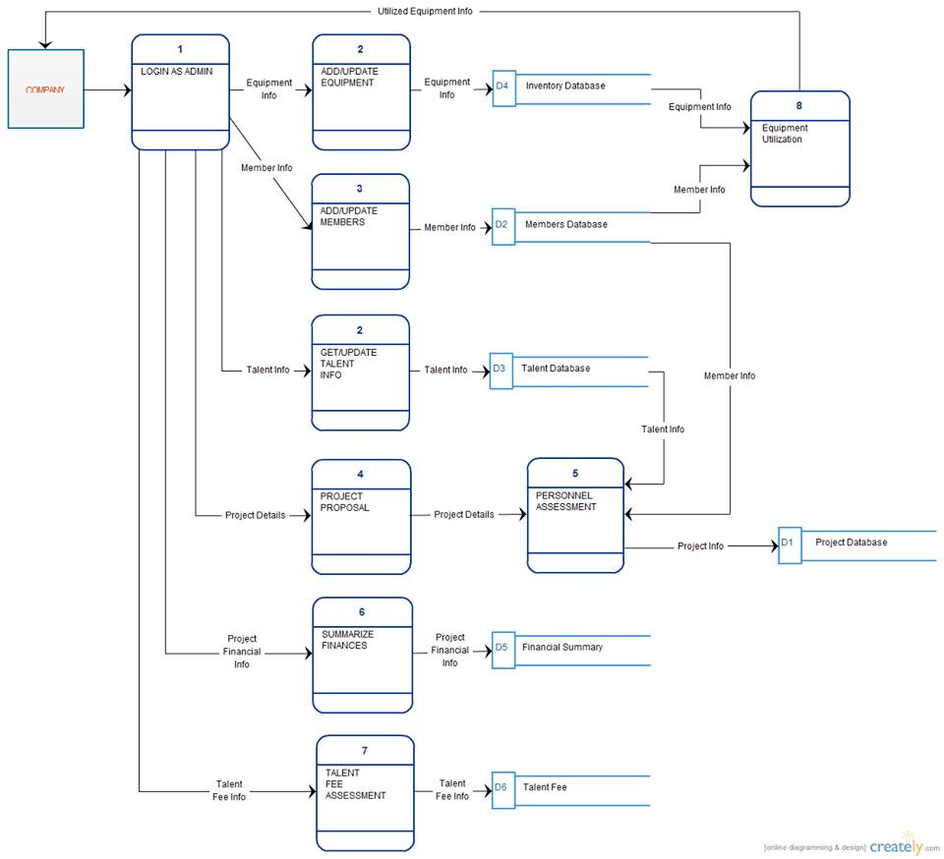

Client Registration and Account Functions

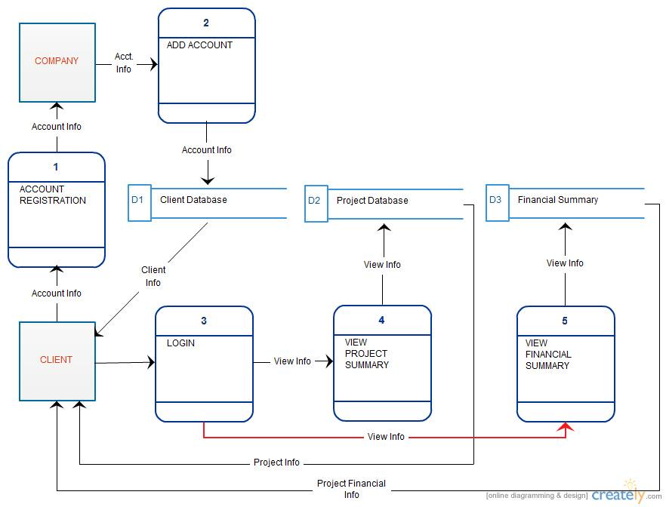

Talent Registration and Account Functions

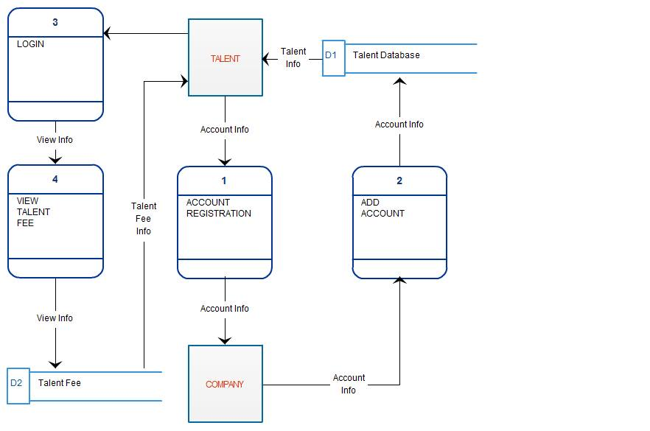

2.3 User Access Levels

Access levels:
- Public – can only view the frontal part of the website
- Registered – depending on the privileges set, can view or even edit/delete data.
- Administrator – has all access levels and privileges and is the one that manages the site.

2.4 Contingencies and Alternate Modes of Operation

On the event that a disaster occurs that may directly affect the system or user, a backup is created of the current system stored on a different location for emergency purposes.

3.0 GETTING STARTED

GETTING STARTED

How a user navigates the system is described here.

3.1 Logging On

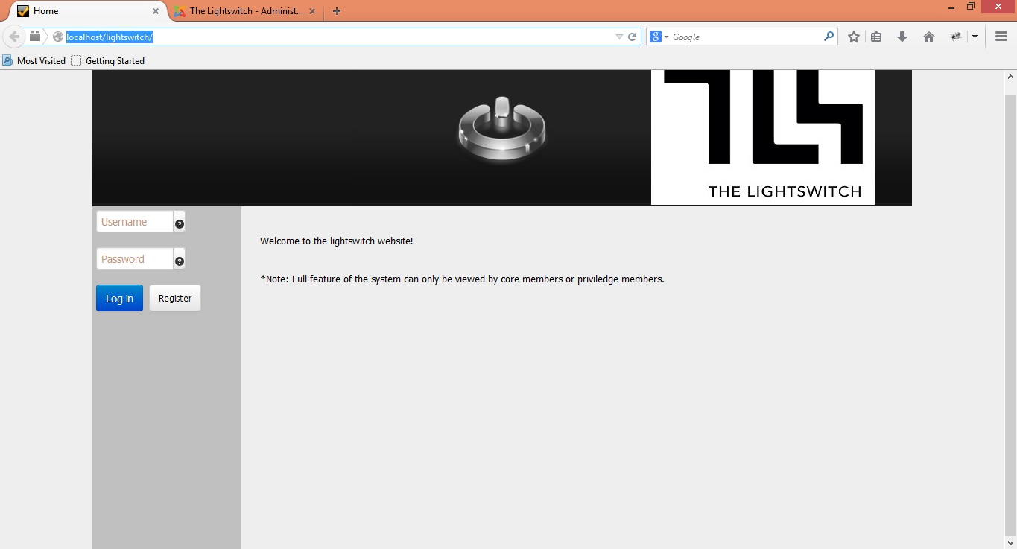

3.2 System Menu
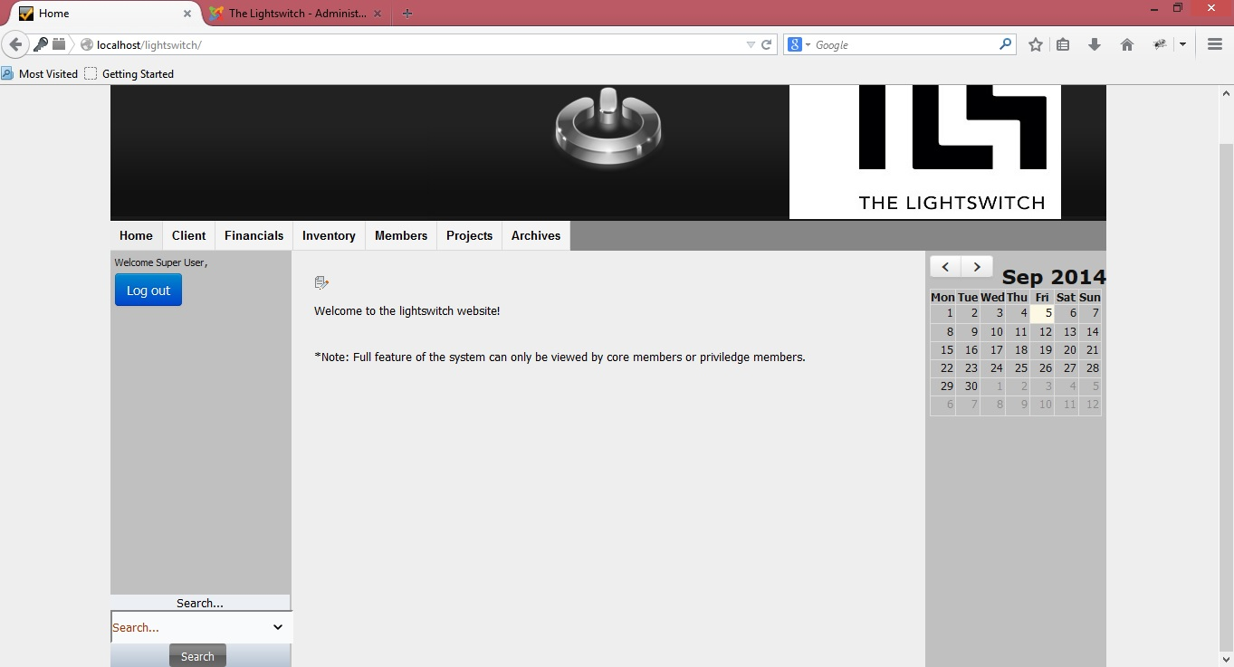

For registered users

3.2 Thelightswitch.co
Site address

3.3 Changing User ID and Password
Password and User ID change is only possible upon requesting it to the site admin.

3.4 Exit System

Pressing Log out button exits the system

